Home Screen:

Account Credentials:

Corporate Address:

Advanced Settings:

Accounts:

Opportunity:

Opportunity Line Item:

Quotes:

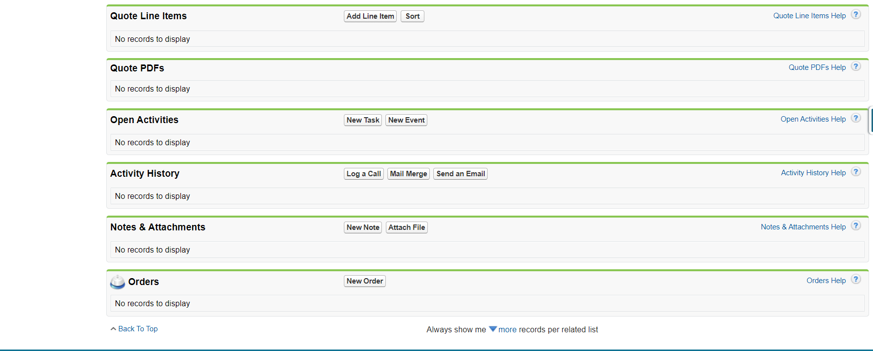

Quote Line Item:

Products:

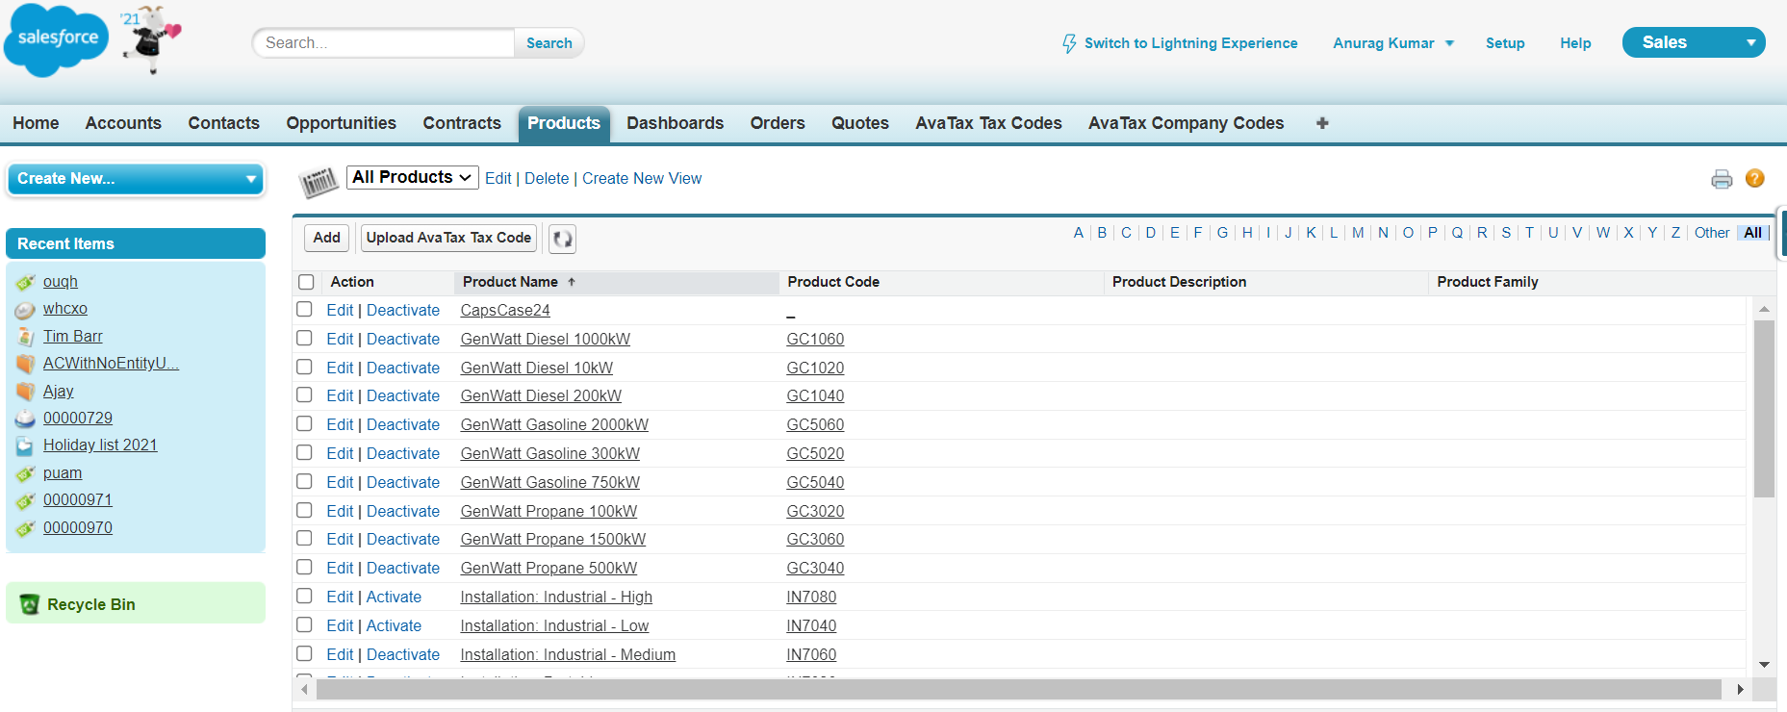

Product List View:

Order:

Order Line Item:

Contracts:

AvaTax Company Codes:

Tax Exemption Certificates:

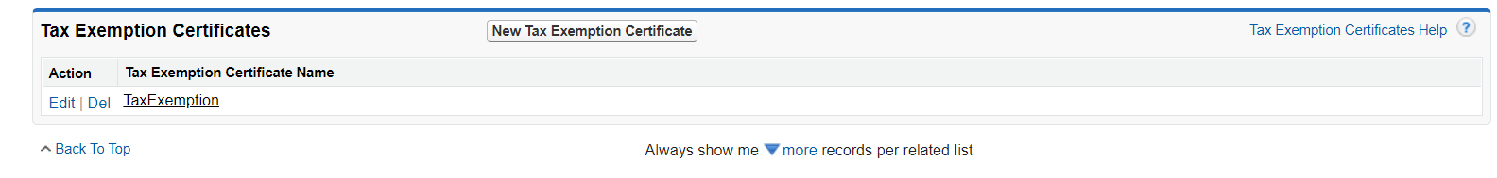

Contacts:

Account Layout: List View

Extra:

